1-Word stem

🌱 What is a Word Stem?
# Source: AI Source: Provided by: [Data Path: Persons Table -> ID Column: 1, Name_En Column: Motasem Essam] -> From: [Chatgpt (GPT-4-turbo)] on [7/22/2025]
A word stem is the core part of a word that carries the main meaning and to which affixes (like prefixes or suffixes) can be added to form different words.

📘 Definition:
# Source: AI Source: Provided by: [Data Path: Persons Table -> ID Column: 1, Name_En Column: Motasem Essam] -> From: [Chatgpt (GPT-4-turbo)] on [7/22/2025]
A stem is the base form of a word, often made up of a root and sometimes other morphemes, which can accept further inflection or derivation.

🧠 Key Point:
# Source: AI Source: Provided by: [Data Path: Persons Table -> ID Column: 1, Name_En Column: Motasem Essam] -> From: [Chatgpt (GPT-4-turbo)] on [7/22/2025]
- A stem is what’s left after removing inflectional endings (like -ed, -s, -ing).
- It may not always be a "real word" on its own, but it’s the form to which grammatical changes are made.

🔍 Examples:
# Source: AI Source: Provided by: [Data Path: Persons Table -> ID Column: 1, Name_En Column: Motasem Essam] -> From: [Chatgpt (GPT-4-turbo)] on [7/22/2025]
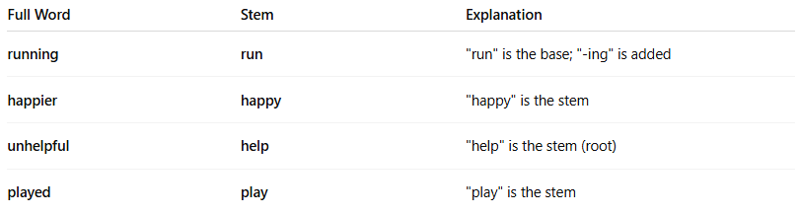

Full Word | Stem | Explanation
running | run | "run" is the base; "-ing" is added
happier | happy | "happy" is the stem
unhelpful | help | "help" is the stem (root)
played | play | "play" is the stem

🧪 Stem vs. Root vs. Base:
# Source: AI Source: Provided by: [Data Path: Persons Table -> ID Column: 1, Name_En Column: Motasem Essam] -> From: [Chatgpt (GPT-4-turbo)] on [7/22/2025]
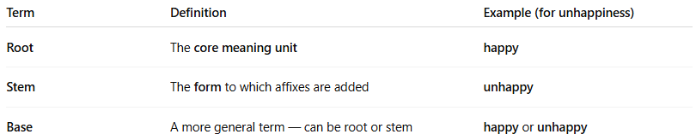
Term | Definition | Example (for unhappiness)
Root | The core meaning unit | happy
Stem | The form to which affixes are added | unhappy
Base | A more general term — can be root or stem | happy or unhappy

✅ Summary:
# Source: AI Source: Provided by: [Data Path: Persons Table -> ID Column: 1, Name_En Column: Motasem Essam] -> From: [Chatgpt (GPT-4-turbo)] on [7/22/2025]
A word stem is the part of a word that remains after removing inflectional endings, and to which prefixes or suffixes can be attached. It holds the core meaning of the word.

2-Word Root

🌿 What is a Word Root?
# Source: AI Source: Provided by: [Data Path: Persons Table -> ID Column: 1, Name_En Column: Motasem Essam] -> From: [Chatgpt (GPT-4-turbo)] on [7/22/2025]
A root is the most basic part of a word — the core morpheme that carries the primary meaning. It cannot be broken down into smaller meaningful parts.

📘 Definition:
# Source: AI Source: Provided by: [Data Path: Persons Table -> ID Column: 1, Name_En Column: Motasem Essam] -> From: [Chatgpt (GPT-4-turbo)] on [7/22/2025]
A root is the original, core part of a word that contains the essential meaning and cannot be divided further into smaller meaningful elements.

🧠 Key Points:
# Source: AI Source: Provided by: [Data Path: Persons Table -> ID Column: 1, Name_En Column: Motasem Essam] -> From: [Chatgpt (GPT-4-turbo)] on [7/22/2025]
- A root is often not a complete word on its own.
- It is the foundation from which stems, bases, and complex words are built.
- Roots can come from various languages, especially Latin and Greek in English.

🔍 Examples:
# Source: AI Source: Provided by: [Data Path: Persons Table -> ID Column: 1, Name_En Column: Motasem Essam] -> From: [Chatgpt (GPT-4-turbo)] on [7/22/2025]
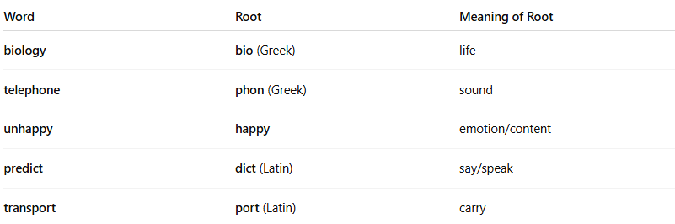
Word | Root | Meaning of Root
biology | bio (Greek) | life
telephone | phon (Greek) | sound
unhappy | happy | emotion/content
predict | dict (Latin) | say/speak
transport | port (Latin) | carry

📦 Root vs. Stem vs. Base:
# Source: AI Source: Provided by: [Data Path: Persons Table -> ID Column: 1, Name_En Column: Motasem Essam] -> From: [Chatgpt (GPT-4-turbo)] on [7/22/2025]
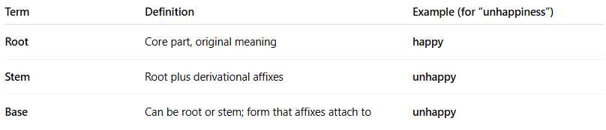
Term | Definition | Example (for “unhappiness”)
Root | Core part, original meaning | happy
Stem | Root plus derivational affixes | unhappy
Base | Can be root or stem; form that affixes attach to | unhappy

📚 Types of Roots:
# Source: AI Source: Provided by: [Data Path: Persons Table -> ID Column: 1, Name_En Column: Motasem Essam] -> From: [Chatgpt (GPT-4-turbo)] on [7/22/2025]
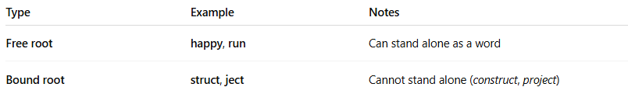
Type | Example | Notes
Free root | happy, run | Can stand alone as a word
Bound root | struct, ject | Cannot stand alone (construct, project)

✅ Summary:
# Source: AI Source: Provided by: [Data Path: Persons Table -> ID Column: 1, Name_En Column: Motasem Essam] -> From: [Chatgpt (GPT-4-turbo)] on [7/22/2025]
A word root is the basic building block of a word — it carries the core meaning and is used to form more complex words by adding prefixes, suffixes, or both.

3-Word Base

🧱 What is a Word Base?
# Source: AI Source: Provided by: [Data Path: Persons Table -> ID Column: 1, Name_En Column: Motasem Essam] -> From: [Chatgpt (GPT-4-turbo)] on [7/22/2025]
A word base is the part of a word to which affixes (prefixes or suffixes) are attached. It can be a root, a stem, or even a complete word.

📘 Definition:
# Source: AI Source: Provided by: [Data Path: Persons Table -> ID Column: 1, Name_En Column: Motasem Essam] -> From: [Chatgpt (GPT-4-turbo)] on [7/22/2025]
A base is the form of a word to which affixes are added. It may be a root (like struct), a stem (like unhappy), or even a fully formed word.

🧠 Key Point:
# Source: AI Source: Provided by: [Data Path: Persons Table -> ID Column: 1, Name_En Column: Motasem Essam] -> From: [Chatgpt (GPT-4-turbo)] on [7/22/2025]
- The base is a general term.
- It refers to any part of a word that can accept an affix.
- It is not always the root or stem, but it plays a similar role.

🔍 Examples:
# Source: AI Source: Provided by: [Data Path: Persons Table -> ID Column: 1, Name_En Column: Motasem Essam] -> From: [Chatgpt (GPT-4-turbo)] on [7/22/2025]
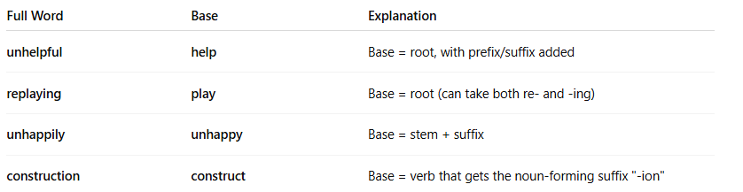
Full Word | Base | Explanation
unhelpful | help | Base = root, with prefix/suffix added
replaying | play | Base = root (can take both re- and -ing)
unhappily | unhappy | Base = stem + suffix
construction | construct | Base = verb that gets the noun-forming suffix "-ion"

🧩 Difference Between Base, Root, and Stem:
# Source: AI Source: Provided by: [Data Path: Persons Table -> ID Column: 1, Name_En Column: Motasem Essam] -> From: [Chatgpt (GPT-4-turbo)] on [7/22/2025]
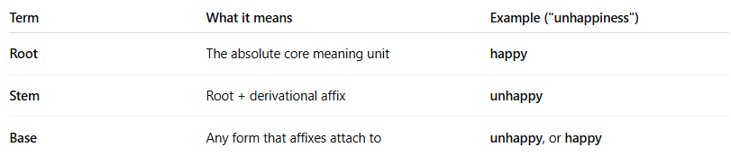
Term | What it means | Example ("unhappiness")
Root | The absolute core meaning unit | happy
Stem | Root + derivational affix | unhappy
Base | Any form that affixes attach to | unhappy, or happy

✅ Summary:
# Source: AI Source: Provided by: [Data Path: Persons Table -> ID Column: 1, Name_En Column: Motasem Essam] -> From: [Chatgpt (GPT-4-turbo)] on [7/22/2025]
A word base is the form of a word to which affixes are added. It may be a root, a stem, or even a full word. The term "base" is flexible and used when you don’t need to specify the exact structure.

